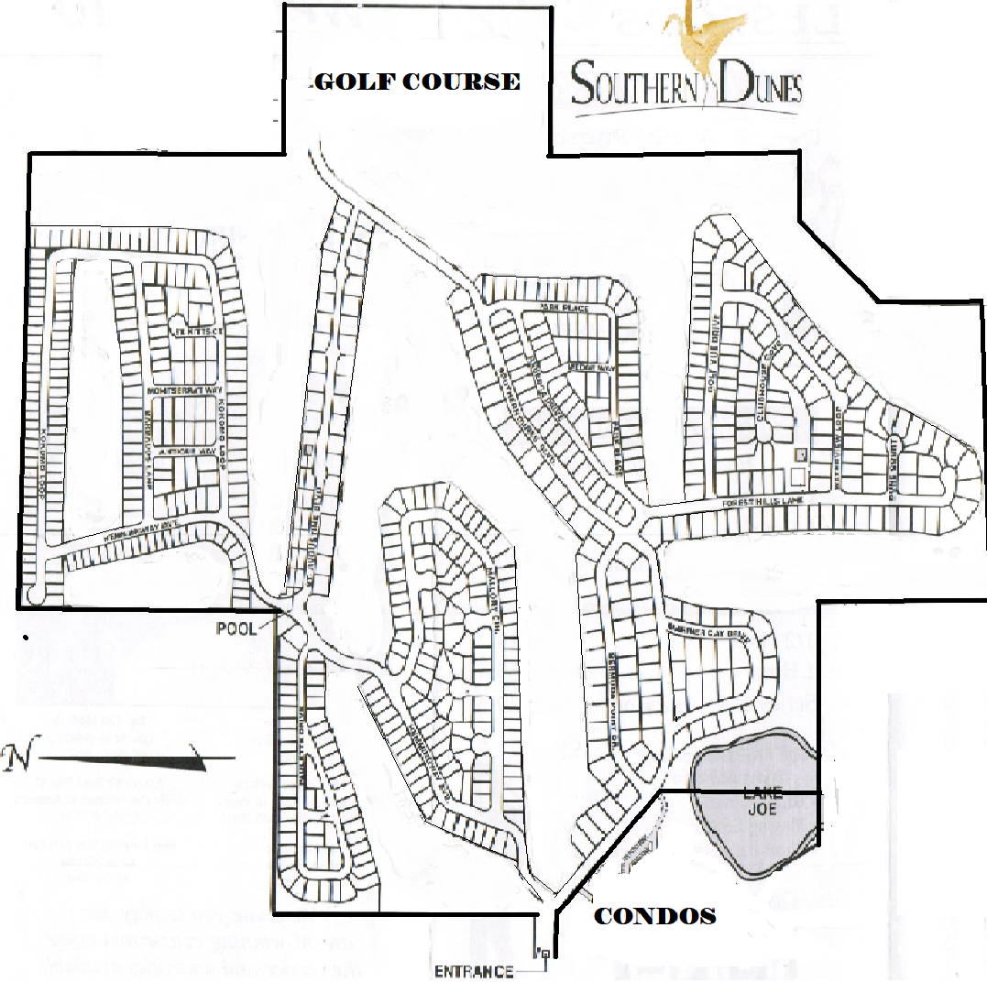
MARINER CAY & MARINER LOOP
MALLORY CIRCLE
MALLORY CIRCLE
SOUTHERN DUNES BLVD
HADLEY WAY
KEY LARGO CT
CLUBHOUSE COVE
PAULETTE DR
MARATHON CT
KEY WEST
DUVAL CT
PARK PL
BERMUDA POINTE DR.

REBECCA DR
FOREST HILLS LN
WATERVIEW LOOP
DUNES CT
GULF VUE DR
PARK PL
WEDGE WAY
MONSERRAT WAY
ANTIGUA WAY
ST. KITTS
BARBADOS LANE
ST. AUGUSTINE
KOKOMO LOOP
KOKOMO LOOP
HEMINGWAY AVE
HEMINGWAY AVE

